Local Sustainability Initiatives

Suburbs in the Netherlands

M. Bakker
S2748630

Bachelor’s thesis Human Geography and Planning
Tutor: MSc. B. J. Kuper

12-06-2017

Colophon

Bachelor’s thesis

Title: Local Sustainability Initiatives
Subtitle: Suburbs in the Netherlands

Author: Marieke Bakker
m.bakker.43@student.rug.nl
Student number: S2748630

University: University of Groningen
Faculty: Faculty of Spatial Sciences
Study: B.S. Human Geography and Planning
Tutor: MSc B.J. Kuper

Place: Groningen

Date: 12-06-2017

Version: Final Version

Abstract
Sustainability is a big issue that faces all people. A lot of different actors, such as governments and citizens, have already taken some initiatives in order to contribute to a sustainable development of the society. Surprisingly, there are less local sustainability initiatives in suburbs than in central cities and rural municipalities in the United States. Citizens of a suburb cover a large part of the population, they could make a big contribution to sustainable development.

This research is focusing on local sustainability initiatives among citizens of suburbs in the Netherlands. The research is examining if there are less local sustainability initiatives in suburbs in the Netherlands as well, and if so, it examines why there are less initiatives. The research is based on a questionnaire survey conducted in Leeuwarden. The suburb Zuiderburen is being compared with a residential area closer to the inner city, Aldlân, to examine why there would be less sustainability initiatives in a suburb than in a residential area in the inner city. Based on a statistical analysis, results have been obtained.
It is important to figure out if and why there are less local sustainability initiatives in suburbs, so municipalities can adapt their policy in order to stimulate more local sustainability initiatives in suburbs.

The result of the research is remarkable. It appears to be that there are not explicitly less local sustainability initiatives among citizens of suburbs in the Netherlands than in residential areas in the inner city. There is no difference between the number of local sustainability initiatives. There is only a difference in the highest level of satisfaction about the sustainability policy of the municipality of Leeuwarden. So there is a possibility for the municipality to increase and stimulate local sustainability initiatives in suburbs. The municipality should investigate why the satisfaction is higher in Aldlân than in Zuiderburen. Subsequently this data could be used to improve the level of satisfaction of the citizens of Zuiderburen.
To explain why there is a difference in the number of local sustainability initiatives in suburbs between the United States and the Netherlands, it is recommendable to do further research on this finding.

Table of content
1. Introduction 2
Background 2
Research problem 2
Hypothesis 2
Thesis outline 2
2. Theoretical Framework 2
Sustainability 2
Bottom-up 2
Suburbs 2
Conceptual Model 2
3. Methodology 2
Research method 2
Data collection 2
Statistical analysis 2
Ethical practice 2
4. Results 2
Distribution Aldlân and Zuiderburen 2
Current sustainability policy 2
Different perceptions 2
5. Conclusion 2
Discussion 2
Reflection 2
Recommendations 2
6. References 2
7. Appendices 2
Appendix 1 – Survey questions (in Dutch) 2
Appendix 2 – Relevant results statistical analysis SPSS 2
Appendix 3 – Map Leeuwarden ArcGIS 2
Appendix 4 – Checklist for ethical survey questions 2
Appendix 5 – Data analysis scheme 2
Appendix 6 – Word web for orientation of the subject 2
Appendix 7 – Timetable 2

1. Introduction

Background
These days, promotion for sustainability is very common. The term sustainability has also become popular in governance policy. But where does this concept come from?
Sustainability as a policy concept has its origin in the Brundtland Report of 1987. Environmental concerns are very important, but there is also a big focus on inter-generational equity (Kuhlman et al., 2010). A progressive transformation of the economy and the society is needed for sustainability. Governments are playing an important role regarding to sustainability (Cossement, 2015). Governments try to develop sustainability policies to provide public services that protect the environment. But there is also a need for bottom-up action. People need to be engaged in governance policy, this creates political legitimacy over time, which is important for local action and can lead to more sustainability policy adoption (Homsy et al., 2014).
Homsy et al. (2014) argue that in the United States both central cities and rural municipalities have higher environmental policy adoption scores than suburbs. This is remarkable, because most of the citizens of a suburb are higher educated and have a greater capacity. Level of educational and the presence of a citizen commission tasked with sustainability issues increase adoption of sustainability strategies. Besides, the role of civic capacity is important, also particularly in smaller places (Homsy et al., 2014). Based on these two facts, the expectation would be that suburbs would be more sustainable.

The aim of this research is to examine whether there are less local sustainability initiatives in suburbs in the Netherlands as well. And if so, it tries to explain why suburbs are less sustainable and how municipalities could improve this. All actors should be responsible for making contributions to the process of sustainability. This is a key to success (Sinclair et al., 2016). Pettibone (2014) confirms this. Sustainability needs citizens, this means that sustainability requires the active engagement of citizens, it also needs the citizens of suburbs. Sustainability calls for changes and to make a big change in the world, all actors should be included (Pettibone, 2014). Therefore the social relevance is high. Since there is no clear answer yet why there are less sustainability initiatives by citizens in suburbs, the scientific relevance of this research is high as well. There is a data gap and this data might be relevant for governments.

Because sustainable development is such a broad concept, for this research there will be a focus on a subtheme of sustainable development. This subtheme is about energy saving initiatives by citizens, such as the purchase of solar panels.

Research problem
The research focuses on the suburbs in the Netherlands, the so-called ‘Vinexwijken’. The name ‘Vinex’ is an abbreviation of ‘Vierde Nota Ruimelijke Ordening Extra’ from 1991. The ‘Vinexwijken’ are major areas which are usually built on the edge of cities (Geertsma, 2017). For this research, the term suburbs will be constantly used, but this refers to the Dutch ‘Vinexwijken’ as well.

Stimulating sustainable initiatives by citizens in general is very important. It is a good development that there are already local sustainability initiatives like in cities and rural municipalities. But the fact that there are barely any local sustainability initiatives in suburbs is concerning. These citizens have a big responsibility, like every other actor has, and can make a significant contribution to sustainable development (Sinclair et al., 2016). Therefore municipalities have to figure out how they can stimulate local sustainability initiatives by citizens in suburbs.
The aim of this research is to examine if there are less local sustainability initiatives in suburbs of the Netherlands as well. The additional aim is to find an appropriate way for municipalities in the Netherlands to stimulate local sustainability initiatives in suburbs. Eventually, this has to lead to a contribution of suburb citizens to a sustainable development.

The corresponding central question of this research is, how can municipalities in the Netherlands stimulate local sustainability initiatives by citizens in suburbs?

The research is conducted in the city of Leeuwarden. The municipality of Leeuwarden states that they have a clear policy concerning sustainability (Gemeente Leeuwarden, 2017).
The focus will be on the suburb Zuiderburen, which is located in the south of Leeuwarden, see figure 1. Zuiderburen has 5835 inhabitants and households with children have the highest share with 57 percent. The average income per resident is 25.900 Euros. Finally, 80 percent of the houses are owner-occupied houses, 20 percent are rented houses and most houses, 98 percent, were build after the year 2000 (CBS, 2016). To make it a valuable research, this suburb will be compared with a residential area closer to the inner city of Leeuwarden, Aldlân. Aldlân is divided into two parts, Aldlân West and Aldlân East. In total Aldlân has 6630 inhabitants. The average income per resident is 20.400 Euros. Single households have the highest share with 40 percent, there are 55 percent owner-occupied houses and 45 percent rented houses. Almost all houses, 99 percent, were build before the year 2000 (CBS, 2016).
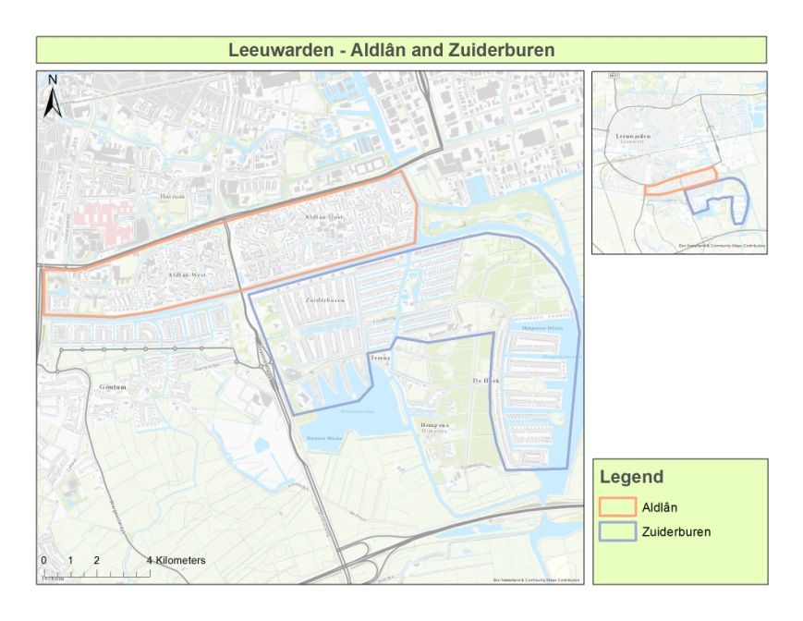

Figure 1: City of Leeuwarden (ArcGIS, 2017)

The reason for this comparison is to examine if there are less sustainability initiatives by citizens in Dutch suburbs as well, which was concluded by Homsy et al. (2014) in the United States.
The secondary questions are:
- How are the sustainable initiatives by citizens divided in the Netherlands? Are there any differences between citizens in residential areas in the inner cities and citizens in suburbs?
- How clear and effective is the current policy concerning sustainable citizen initiatives in the municipality of Leeuwarden according to the citizens?
- What are the overall perceptions and attitudes about sustainability between the citizens of a suburb and a residential area in the inner city?

Hypothesis
When considering the finding of Homsy et al. (2014), the expectation of the outcome is that there will be less local sustainability initiatives in suburbs than in residential areas in inner cities in the Netherlands. This is a logical hypothesis, because the citizens of suburbs in the Netherlands have the same characteristics as the citizens of the suburbs in the United States. Namely, higher educated and a greater financial capacity. Besides, the location of suburbs in the Netherlands is similar as in the United States, namely on the edge of cities. So in general the suburbs are comparable, therefore it is possible to expect that the number of local sustainability initiatives in suburbs in the Netherlands is lower, such as in the United States.

Thesis outline
The following chapter provides a theoretical framework where all the important concepts will be explained and the conceptual model of the research will be shown.
In chapter 3 the methodology, including the research method and the statistical analysis, will be explained. The results are presented in chapter 4. Based on these results, a conclusion will be drawn and an answer to the research question will be provided in chapter 5. This conclusion will be discussed, and a reflection of the research and some recommendations will be done.
Chapter 6 contains the references and chapter 7 the accompanying appendices.

2. Theoretical Framework

Sustainability
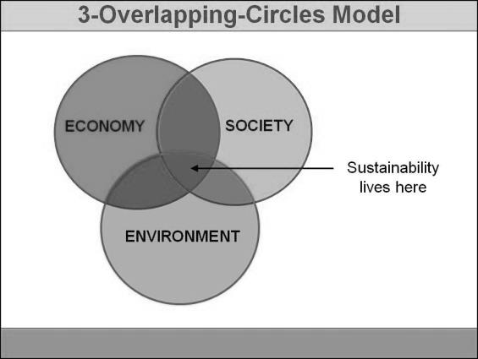
Sustainability is an important concept, because of the global climate change. Kuhlman et al. (2010) argue that sustainability, as a policy concept, has its origin in the Brundtland Report of 1987. That document was caught up with the tension between the ambition of humanity towards a better life on the one hand and the limitations imposed by nature on the other hand. Over time, the concept has been re-interpreted as encompassing three dimensions, namely social, economic and environmental (Kuhlman et al., 2010). In figure 2 one can see a three-overlapping-circles model of sustainability, the three dimensions are clearly shown. When the circles overlap each other, sustainability will be achieved (Willard, 2010).
Environmental concerns are very important, but in the Brundtland Report is also a big focus on inter-generational equity. People should care for the environment not because of its intrinsic value, but in order to preserve resources for our children. To achieve this, the Brundtland Commission came up with the concept of sustainable development. They defined
sustainable development as ‘development that meets the needs of
the present without compromising the ability of future generations to meet
their own needs’. Sustainability is concerned with the well-being of
Figure 2: 3-Overlapping-Circles Model (Willard, 2010)
future generations (Kuhlman et al., 2010).

The well-being of the present and future generations depends on sustainability (Huckle et al. 1996).
Education is needed for sustainability. Humanity is confronted with a perpetuation of inequalities
between and within nations, more poverty and hunger, and a continuing deterioration of the ecosystems
on which we depend for our well-being. Therefore, an integration of environment and development
concerns and greater attention to them are needed. This will lead to the accomplishment of basic
needs, improved living standards for everyone, better protected and managed ecosystems and a safer,
more successful future (Huckle et al., 1996).

So the well-being of the present and future generations depends on sustainability. Well-being is about capabilities to achieve one’s potential and it should incorporate intangible needs as education and security. Hence well-being is a policy goal, so governments are involved (Kuhlman et al., 2010). It is necessary to move towards more sustainable forms of political economy that meet everyone’s needs (Huckle et al., 1996). The government is playing an important role and therefore the government is involved in the research.
Top-down
The role of the government is important with regard to sustainability and local action. According to Burgess et al. (1998) governments face the challenge of communicating more effectively with citizens about issues of sustainability, because of different styles of communication at different levels. Their article is a comparative analysis of the social and cultural processes through which lay publics understand global environmental problems, and the extent to which understanding is translated into changed practices at individual and household levels. Supporters of a more inclusionary approach in planning theory and practice are also looking for new forms of communicative practice.

Homsy et al. (2014) discuss the role of the government in relation to sustainable initiatives as well. The article focuses on Multilevel governance theory. In this framework, state and federal governments might use regulations to establish broad goals and provide technical or fiscal capacity for local action. Municipalities decide on the appropriate action for each local situation. This coproduction approach causes a flow of knowledge and policy innovation from local governments, down from higher authorities, and horizontally across networks of municipalities (Homsy et al., 2014).
Rosenthal et al. (2015) use also multilevel modelling for looking at climate-related policy. Local government institutional and community variables are strongly associated with climate policy initiatives. In the area of climate protection and environmental policy, cities are playing a leading role. There is little support for the influence of state factors on local government. So the local government, the city, is the appropriate level for climate policy, which corresponds with the theory of Homsy et al. (2014).

According to these articles governance policy about sustainability, especially at the local scale, is important for local action. This finding is valuable for the research problem. Therefore the research focuses on the local government, the policy of the municipality of Leeuwarden.
Regarding the research, it is necessary to examine how the policy of this municipality is regulated. Leeuwarden is working on a sustainable and strong municipality. According to municipality of Leeuwarden (2017) there are several subsidies and funds for sustainable actions of citizens. This applies to both individuals and groups. There is for example a subsidy for ‘saving energy together’ in order to stimulate citizens to consider together solutions to save water and energy in their own environment (Gemeente Leeuwarden, 2017).
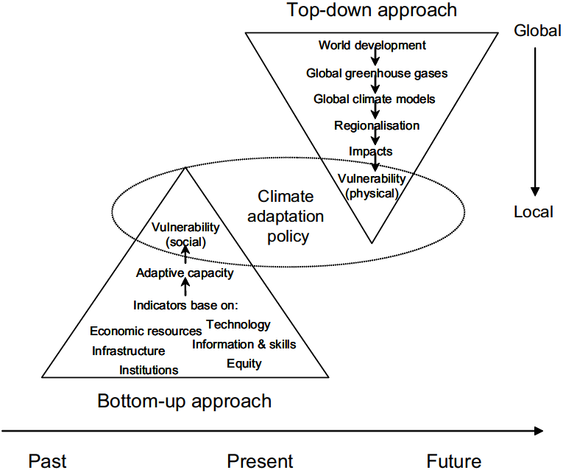
However, according to Burgess et al. (1998), the undoubted challenge is to develop local strategies capable of contributing to global goals by getting support from the public. New approaches to public participation are required. The essentially ‘top-down’ model of communication assumes there is a shortage in public knowledge and understanding of environment issues which needs to be filled by expert knowledge. Hence individuals will accept their own responsibilities and acknowledge the need to change parts of their lifestyles (Burgess et al., 1998).
Figure 3 shows a schematic overview of the difference between the two approaches. Both approaches are supposed to inform decision-making and policy formation, but both in a different way and with different actors (Dessai et al., 2004).
Figure 3: Top-down and bottom-up approaches (Dessai & Hulm, 2004)

Regarding the research problem it is relevant to consider both approaches. Both have significant influence on the research problem.

Bottom-up
Besides the role of the government, sustainability needs citizen participation. Moon et al (2016) argue that devolved decision-making can be more effective in developing and implementing social-ecological policy than top-down approaches. This will lead to better understanding, higher levels of decision acceptance and it encourages commitment to the achievement of outcomes by stakeholders.
Ertio et al. (2017) support bottom-up approaches as well. It is valuable to engage citizens in planning policies. Citizens are driving innovations with the planners being recipients of the outcomes of their innovations. Planners should give citizens opportunities to play an active role in planning. It creates awareness about problems and supports participation of the citizens (Ertio et al., 2017). This awareness is necessary according to Selmon (1996). Citizens and local communities have to believe in the need to adopt more sustainable lifestyles, and act accordingly. Active citizenship and community pride is therefore needed. Citizens have to be encouraged to work together with wider environmental initiatives. The way of managing and planning local sustainability is important (Selmon, 1996).

But according to Huckle et al. (1996), to improve the capacity of the people to address environment and development issues, education is critical for promoting sustainable development. It is also critical for achieving environment and ethical awareness, values and attitudes consistent with sustainable development (Huckle et al., 1996). Nowadays, there is a variety in knowledge and the level of education. Therefore, it could be useful to study knowledge and attitudes of people. When studying the relation of knowledge and concern of people, it is important to take into account the content of the information that different types of people acquire and choose to rely upon (Malka et al., 2009).

So bottom-up approaches are required when concerned with local sustainability. For the research, it is necessary to focus on active engagement of the citizens of the suburbs. The fact of variety in knowledge might be applicable to the research as well.

Suburbs
It is difficult to define the term suburb, because to most people suburbs are characterized along more than one dimension (Harris et al., 2004). Suburbs vary from place to place. There are five dimensions which are commonly emphasized in different countries, these are:
- Peripheral location in relation to a dominant urban centre.
- A partly (or wholly) residential character.
- Low densities, often associated with decentralized patterns of settlement and higher levels of owner-occupation.
- A distinctive culture, or way of life.
- Separate community identities, often embodied in local governments.
These elements have some obvious connections. At the urban periphery, land is usually cheaper, encouraging lower density development and, specifically, the construction of single-family homes for owner-occupation. The people who choose and are able to move to suburbs are likely to be in households with children, well-educated and of upper-class (Harris et al., 2004).
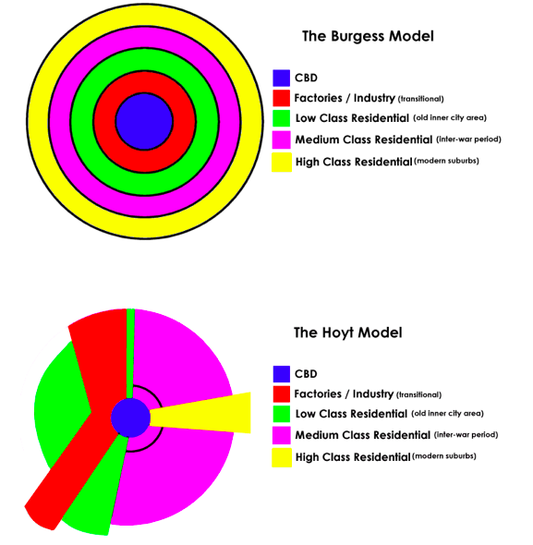
Not only the definition of a suburb varies, the position of a suburb varies as well. In figure 4 there are two different examples of Urban Land Use Models. The first one is the Burgess Zone Model, this model represents the use of urban land as a set of concentric rings (Burgess, 1925). The second one is the Hoyt Sector Model. Hoyt (1939) theorized that cities would tend to grow in wedge-shaped sectors.
Both of the models identify suburban areas, these suburbs are defined as High Class Residential (modern suburbs) in the models. There is a difference in the position of the suburb, but looking at both models, the suburbs are generally located at the edge of the urban area and meant for the higher class (Sultana, 2017).

For this research, looking at the description of the suburb Zuiderburen in chapter one, Zuiderburen fulfil the features of a
Figure 4: Urban Land Use Models (Sultana, 2017)
suburb as well.

Conceptual Model
The conceptual model is a primarily visual representation of the theories underpinning the research and the expected cause-effect relations in the research, see figure 5. It shows which connections will be expected between the variables. It clarifies concepts, factors and relationships within the research.
The next step after the composition of the conceptual model, is to prove the relationships in the model scientifically by the means of a research.

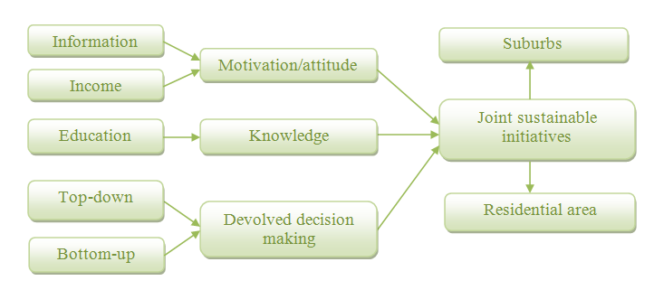
Figure 5: Conceptual Model

3. Methodology

Research method
In order to answer the central question and the secondary questions, a quantitative research method has been chosen. This method gives a more objective outcome, because of the statistical modelling.
Questionnaire survey research is a method for collecting information about people and institutions. It will be used to explore people’s perceptions, attitudes, experiences and spatial interactions in diverse geographical contexts. Survey research is particularly useful for eliciting people’s attitudes and opinions about social, political and environmental issues, so also about sustainability issues (Clifford et al., 2010). In order to answer the central question, it is relevant to examine why citizens of suburbs did not join to start sustainable initiatives yet. Survey research is a tool for gathering information about people’s lives that is not available from published sources (Clifford et al., 2010). So it is an appropriate method to determine what the perceptions of the citizens in the suburbs are about sustainability. This method is also valuable for finding about social interactions. This is useful as well, because differences in local sustainability initiatives could also be explained by differences in social interactions. When the source of the problem is clear, governments know how to adopt their policy for stimulating local sustainability initiatives.
For this research method it is important to take two aspects into account, the number of cases and the representativeness of the sample. The selected sample must be a good representation of the target population. This will lead to a less biased research and gives the possibility to make general statements about the population. Furthermore, the sample size must be large enough to allow an effective statistical analysis of the results (Clifford et al., 2010).

Geographic Information System is used to make a clear map of the research area, this makes the comparison more convenient. This map is displayed in figure 1, it shows the exact location of the suburb Zuiderburen and the exact location of the residential area Aldlân in Leeuwarden.

Data collection
For this research, sixty surveys have been collected in the suburb Zuiderburen, as well as sixty surveys in the residential area Aldlân. The survey has been added in appendix one and is divided into three different themes: individual perceptions, collective perceptions and current sustainability policy. The survey contains twenty-five fixed-response questions, this offers a limited set of responses, and four open-ended questions, this allow participants to craft their own responses. The advantage of these four open-ended questions is that the respondents’ true viewpoints may be better represented (Clifford et al., 2010).

The strategy for data collection is drop and pick-up questionnaires. This involves leaving self-administered questionnaires at people’s homes and picking the surveys up at a later point of time.
By this strategy, simple instructions can be given by dropping off the surveys, and secondly a brief description of the survey effort can be given. The personal contact in dropping off the survey gives response rates close to face-to-face interviews, but with much less time. So this method combines the strengths of interview and self-administrated strategies (Clifford et al., 2010).
In order to reach a representative sample, a stratified sampling strategy is used. This procedure ensures that the sample adequately represents various subgroups. First, the population is divided into subgroups and then samples are chosen randomly or systematically from each subgroup (Clifford et al., 2010). For this research, first a zip code has been chosen randomly, then a specific street and finally the house numbers.

Statistical analysis
The next step after collecting the data was the statistical analysis. To provide an answer on the research question, the perceptions of the two survey groups need to be compared. It is possible that there could exist significant differences in attitude, motivations, knowledge or social interactions between the citizens of the two residential areas.
So two independent groups, the citizens of Zuiderburen and the citizens of Aldlân, were compared. The Mann-Whitney test for two independent samples is an appropriate statistical test, because of two reasons. First, because of the large number of ordinal variables. Second, the sample might not be large enough. The Mann-Whitney test deals with these two factors. The test is used to compare differences between two independent groups when the dependent variable is either ordinal or continuous, but not normally distributed (Moore et al., 2014).
Besides the Mann-Whitney test, two other tests are used for some specific questions which have no ordinal variables. One is the T-test for two independent samples. This test is meant for a question with ratio variables and this test is useful when one want to compare the averages of two populations (Moore et al., 2014).
The other test is the Chi-square test. This test is used to examine whether there is a connection between two nominal variables. It is a measure which compares the set of observed numbers with the set of expected numbers. Therefore it is a comparison between two groups (Moore et al., 2014).

Before the statistical analysis can be performed, all the data had to be entered in Excel. Subsequently, this Excel file has been imported into SPSS. The data analysis scheme in appendix six sets out how and why the primary data will be analyzed.

Ethical practice
The researcher is an outsider in both Zuiderburen and Aldlân, so ethical research is important. According to this ethical research, practitioners should behave with integrity and act in ways that are just, beneficent and respectful. Ethical behaviour protects the rights of individuals, communities and environments involved, or affected, by this research (Clifford et al., 2010). For this research the privacy of the people who live in both areas have to be respected, especially of the respondents. Questions that are too personal should not be asked in the survey. In addition, leading and difficult questions should be avoided. To ensure all these aspects, mainly closed and simple questions are being used. Furthermore, the purpose of the research has to be communicated clearly, as well as what is going to happen with the information of the respondents. Behaving ethically has not just morally reasons, but also a practical reason. By behaving ethically, you maintain public trust (Clifford et al., 2010). For the quality of the survey questions a checklist has been added, see appendix four.

4. Results
This chapter provides the results of the statistical analysis. The secondary questions are being answered and the analysis makes it possible to examine whether the hypothesis can be adopted or not. The hypothesis of testing reads that the average number of local sustainability initiatives in the Netherlands will be equal in both suburbs and residential areas closer to inner cities.

Distribution Aldlân and Zuiderburen
In total, 120 surveys have been collected. From the collected data, 26 of the respondents in Aldlân were male and 34 were female. In Zuiderburen, 35 were male and 25 were female.
The division of property ownership has also been examined. In Aldlân, 6 are rental properties and 54 are owner-occupied property. In Zuiderburen, 4 are rental properties and 56 are owner-occupied properties. Referring to the information in chapter one, the division of property ownership in Zuiderburen is similar to the information, whereas the division in Aldlân deviates. The division in Aldlân supposed to be 55 percent owner-occupied and 45 percent rental (CBS, 2016).
The overall age distribution in figure 6 shows some remarkable differences between the two areas. The age structure of Aldlân is more equal than of Zuiderburen. The age structure of Aldlân is divided in a very young part (24-34) and a more older part (65-74, 75>), whereas the age structure of Zuiderburen is mainly middle-aged. Zuiderburen has high shares in the age categories 45-64 and 55-64.
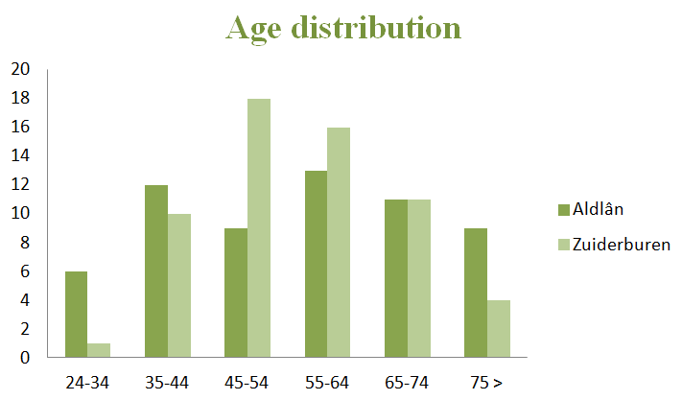
Figure 6: Overall age distribution

Finally, households with children have the highest share in Zuiderburen, namely 53 percent. This corresponds with the features of a suburb. People who choose and are able to move to suburbs are likely to be in households with children (Harris et al., 2004).

Now the overall distribution between the two areas is clear, the following step is answering the first secondary question, ‘how are the sustainable initiatives by citizens divided in the Netherlands? Are there any differences between the citizens in residential areas in the inner cities and the citizens in suburbs?’
According to the finding of Homsy et al. (2014) both central cities and rural municipalities have higher environmental policy adoption scores than suburbs. There are less local sustainability initiatives among citizens in suburbs. As explained in chapter one, it is logical to expect this finding in suburbs in the Netherlands as well.
Furthermore, when looking at the distribution of the education levels of the two different areas in figure 7, it becomes clear that the residents of Zuiderburen are higher educated than the residents of Aldân. This corresponds to the assumption that citizens of suburbs are well-educated and of upper-class (Harris et al., 2004) and therefore have greater financial capacity (Homsy et al., 2014).

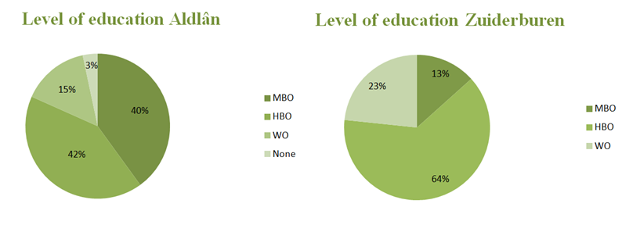
Figure 7: Level of education

According to these two statements of Homsy et al. (2014), the expected answer to the first secondary question is that there are less local sustainability initiatives in suburbs than in residential areas closer to inner cities.
In order to provide an answer to this question, in the survey there has been asked if the residents, both in Aldlân and in Zuiderburen, already join sustainability initiatives. This outcome is represented in figure 8 and shows indeed that more residents in Aldlân already join sustainability initiatives than in Zuiderburen.

Already joining sustainability initiatives | Yes | No
Aldlân | 20 % | 80 %
Zuiderburen | 12 % | 88 %
Figure 8: Participating in joint sustainability initiatives

But according to the results of the statistical analysis, it is not possible to conclude that there are in general less local sustainability initiatives in the suburb Zuiderburen. For the research, a significance level of 5 percent has been used. The Chi-square test provided a significance level of 21,1 percent. So there is not a significant difference between the two areas. The average number of local sustainability initiatives in the Netherlands is equal between suburbs and residential areas closer to inner cities, which is in contrast to the finding of Homsy et al. (2014).

Current sustainability policy
The second secondary question is ‘how clear and effective is the current policy concerning sustainable citizen initiatives in the municipality of Leeuwarden according to the citizens?’
It is valuable to engage citizens in planning policies (Ertio et al., 2017). The municipality of Leeuwarden is working on a sustainable and strong municipality. There are several subsides and funds for sustainable actions of citizens (Gemeente Leeuwarden, 2017). So the municipality of Leeuwarden is concerned with opportunities for starting local sustainability initiatives. But what is the opinion of the citizens of Aldlân and Zuiderburen on the policy? Could there be a difference between the two residential areas?
The Mann-Whitney test determined that there is not a significant difference in the degree of satisfaction among the citizens about the policy. The average satisfaction of communication with the municipality and the average satisfaction of opportunities at the municipality are similar between the two groups.
But when the highest level of satisfaction (‘helemaal eens’) is being examined, the conclusion can be made that there is a significant difference between the two groups. The T-test for two independent samples provided a significance level of 0,08 percent, which is lower than the significance level of the research of 5 percent. So there is a difference in the highest level of general satisfaction about the sustainability policy of the municipality. The satisfaction is lower among the citizens in Zuiderburen. According to Malka et al. (2009) it is relevant to consider the content of the information that different people acquire and choose to rely upon. Therefore, it could be useful to study knowledge and attitudes of people, like of the citizens of Zuiderburen, to examine where the cause of this difference occur.

Different perceptions
The third secondary question is ‘what are the overall perceptions and attitudes about sustainability between the citizens of a suburb and a residential area in the inner city?’.
The degree of openness towards local sustainability initiatives appears to be insignificant, with a significance level of 95,6 percent. Because of the high level of significance, the degree of openness towards local sustainability initiatives of the citizens between both areas is very similar. This is also confirmed by the Mean Rank score for each group. The Mean Rank of Aldlân is 60,3 and the Mean Rank of Zuiderburen is 60,7. In this case, there is a similar open attitude towards local sustainability initiatives which is critical for sustainable development (Huckle et al. 1996). But as shown in figure 8, the number of citizens who already join sustainability initiatives differs between Aldlân and Zuiderburen.
However, looking at individual sustainable measures per household in figure 9, it appears that the number of citizens who already took individual sustainable measures is similar between Aldlân and Zuiderburen. So, there is a difference in attitude in Zuiderburen between the openness towards local sustainability initiatives and towards individual sustainable measures.
Individual sustainable measures per household | Yes | No
Aldlân | 62% | 38%
Zuiderburen | 63% | 37%
Figure 9: Individual sustainable measures per household
Furthermore, the Mann-Whitney test determined that there is neither a significant difference in the degree of contact with the neighbourhood between Aldlân and Zuiderburen. The level of significance is 6,9 percent. This is close to the significance level of 5 percent. Therefore it is not very strong. Looking at the Mean Rank score, it becomes clear that the degree of mutual contact with the neighbourhood is higher in Zuiderburen (65,4) than in Aldlân (55,6). So within the sample there is a difference in the degree of contact with the neighbourhood. But it is not possible to conclude this for the population.
The motivation of implementing sustainable measures, both individually and jointly, is similar between the citizens of Aldlân and Zuiderburen. There is not a significant difference in motivation. The average numbers of motivations based on protecting the environment or cost saving are similar between Aldlân and Zuiderburen. The only remarkable observation, looking at the Mean Rank score for cost saving motivation, is that the Mean Rank score of Aldlân is much higher (65,8) than of Zuiderburen (55,2). So there are more citizens in Aldlân who would implement sustainable measures in order to save costs than in Zuiderburen. This financial aspect is confirmed by the statement whether sustainable measures are financial feasible. The financial feasibility is insignificant as well, but not very strong, only 5,2 percent. The Mean Rank score of Zuiderburen is higher (66,4) than of Aldlân (54,6), so it is more financial feasible for citizens in Zuiderburen. Figure 10 shows that the financial aspect is the most relevant motivation in Aldlân. The greener the more people have chosen for this motivation.
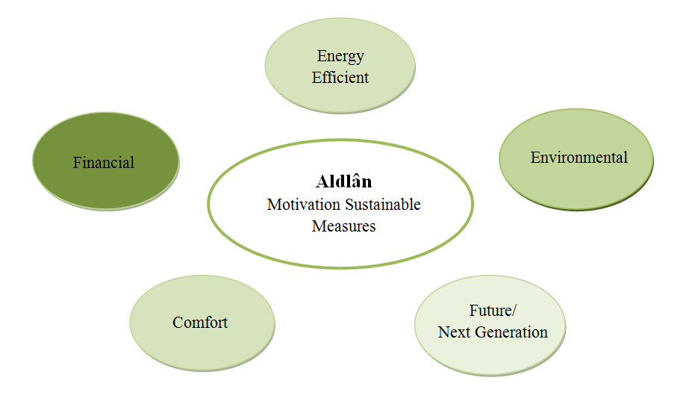

Figure 10: Motivations Sustainable Measures Aldlân
The financial motivation of citizens of Aldlân corresponds with the finding that there live more higher educated people and of upper-class in a suburb like Zuiderburen, which can lead to a greater financial capacity so saving costs is less an issue (Harris et al., 2004).
The most relevant motivation in Zuiderburen is because of the environment, see figure 11. An explanation for this difference in motivation might be the level of education. According to Huckle et al. (1996) education is critical for promoting sustainable development and for achieving environment and ethical awareness. Citizens of suburbs are higher educated and therefore might be more aware of sustainable development.
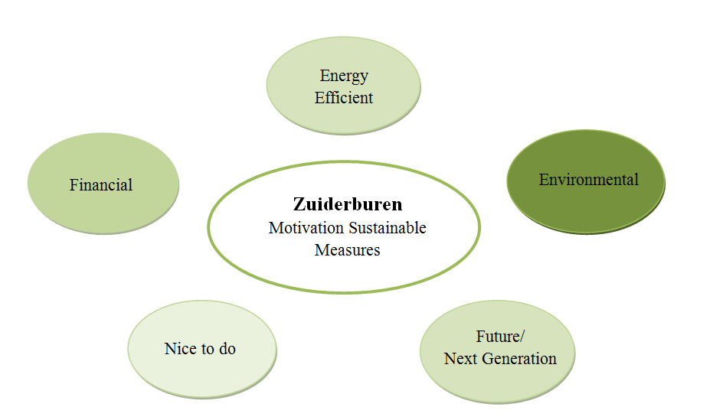

Figure 11: Motivations Sustainable Measures Zuiderburen

5. Conclusion

Discussion
The goal of this research was to examine whether there are less local sustainability initiatives among citizens of a suburb than among citizens of a residential area in the inner city in the Netherlands.
This was based on the finding of Homsy et al. (2014) that there are less local sustainability initiatives among citizens of suburbs in the United States. This might be the same for the Netherlands. The research question was ‘how can municipalities in the Netherlands stimulate local sustainability initiatives by citizens in suburbs?’

The research has shown that there is no significant difference in the number of local sustainability initiatives between citizens of a suburb and of a residential area in the inner city in the Netherlands. This is remarkable, because this is in conflict with the finding of Homsy et al. (2014).
The characteristics of the citizens of the suburb Zuiderburen are in line with the general characteristics of citizens of a suburb. Namely, households with children, well-educated and upper-class (Harris et al., 2004). This makes it remarkable as well that there is a difference between the number of local sustainability initiatives of citizens of suburbs in the United States and of suburbs in the Netherlands in regard to residential areas.
Both groups of Aldlân and Zuiderburen have an open attitude towards local sustainability initiatives and there is not an explicit difference between the motivations of the application of sustainable measures. So both citizen groups want to engage, which is important for sustainable development (Huckle et al., 1996). However, within Zuiderburen there is a difference in openness towards local sustainability initiatives and towards individual sustainable measures. Already taken individual sustainable measures have a clear majority. But according to the statistical test, there is not a significant difference between Aldlân and Zuiderburen, which is remarkable.

An explanation for this result could be that there is still a difference between the number of local sustainability initiatives between the two groups, but that this difference is so small that a larger number of cases is needed to prove this. The sample of this research might not be big enough to uncover this difference.
Another explanation could be that there is simply not a difference in the number of local sustainability initiatives between the two areas. This might be caused through a different attitude of the Dutch people than of the American people or better opportunities and/or communication in the Netherlands concerning sustainability initiatives.

Eventually, one significant difference has been identified. There is a difference in the highest level of satisfaction concerning the policy of the municipality of Leeuwarden. Maybe the citizens could be more engaged, this could lead to more awareness about environmental issues and the need of sustainability and eventually to citizen participation (Ertio et al., 2017). This could be a focus point for the municipality to improve, so the number of local sustainability initiatives in the suburb might increase.

Reflection
Questionnaire surveys have to be as objective as possible, but the reality shows this is a difficult requirement. However, the checklist in appendix four has helped well to stay as objective as possible and to behave ethically.
A problem which occurred within the survey is that some respondents had chosen for multiple answers at questions where only one answer was allowed. This is solved by taking constantly the same answer. This answer was always chosen, when respondents had chosen for multiple answers.
Besides, not every question of the survey was answered by some of the respondents. Therefore, some variables are missing and have been entered as 999. These variables are excluded from the analysis.
Varied views about what counts as individual sustainable measures occurred as well. Some of the respondents viewed local sustainability initiatives, such as solar panels, as individual sustainable measures as well and some of the respondents didn’t assign this to individual sustainable measures. For this problem, both answers have been taken, so individually as jointly, into the analysis. The reason for this decision is that people could actually have purchased solar panels only by themselves.

The strategy for the data collection worked well. The respondents were in general very willing to complete the survey. A high response percentage was being achieved.

Reliability of the research is also important. Are the results of the research stable? When the research would be repeated, would the same results occur? It is possible that there will be a deviation in the results, when other respondents in the two residential areas are chosen. They could have a different opinion about sustainability initiatives. Besides, when the research will be done in another part of the Netherlands, the results could deviate as well.

When reflecting at the conclusions, it is important to have a look at the validity of the research. ‘Do I know what I wanted to know?’ After collecting the data and the statistical analysis this has been achieved, the central question has been answered. But the reason for the finding that there is a difference between the United States and the Netherlands has not been examined.

Recommendations
On the basis of the conclusions some recommendations can be made. Municipalities should make a change in their policy regarding sustainability initiatives in order to stimulate local sustainability initiatives in suburbs. Governments are playing a very important role regarding sustainability (Cossement, 2015). It is valuable to engage the citizens in planning policies, this creates more awareness and citizen participation (Ertio et al., 2017). Therefore, adapting the policy might lead to improved opportunities and communication, and eventually greater satisfaction.

After this research, there is still a question left. What is the reason for the difference in the number of local sustainability initiatives between citizens of suburbs in the Netherlands and citizens of suburbs in the United States? To explain the cause of this difference, it is recommendable to do further research on this finding. It might be useful to study the knowledge and attitudes of the Dutch and the American people (Malka et al., 2009).

6. References
Burgess, J., Harrison, C. M. & Filius, P. (1998). Environmental Communication and the Cultural Politics of Environmental Citizenship. Environment and Planning, 30 (1), 1445-1460.

CBS (2016). CBS in uw Buurt. Accessed at 31-05-2017 through http://www.cbsinuwbuurt.nl/.

Clifford, N., French, S.& Valentine, G. (2010). Key Methods in Geography. Second edition. London: SAGE Publications.

Cossement, P. (2015). Sustainable Governance, a new way of governance? Leading Boards. 05-03-2015.

Duurzaam Aldlân (2017). Werkgroep Duurzaam Aldlân Leeuwarden. Assessed at 02-03-2016 through http://www.duurzaamaldlan.nl/. Leeuwarden.

Ertio, T. P. & Bhagwatwar, A. (2017). Citizens as planners: Harnessing information and values from the bottom-up. International Journal of Information Management, 37(3), 111-113.

Geertsma, P. (2017). Wat zijn Vinexwijken? Assessed at 27-01-2017 through http://www.technischwerken.nl/kennisbank/management-kennisbank/wat-zijn-vinexwijken/ .

Gemeente Leeuwarden. Duurzaamheid. Assessed at 02-03-2017 through https://www.leeuwarden.nl/nl. Leeuwarden: Gemeente Leeuwarden.

Harris, R. & Larkham. P. J. (2004). Changing Suburbs: Foundation, Form and Function. New York: Routledge.

Homsy, G. C. & Warner, E. W. (2014). Cities and Sustainability: Polycentric Action and Multilevel Governance. SAGE Journals, 51 (1), 46-73.

Huckle, J. & Sterling, S. (1996). Education for Sustainability. Abingdon: Earthscan.

Kuhlman, T. & Farrington, J. (2010). What is Sustainability? Sustainability, 2 (110), 3436-3448.

Malka, A., Krosnick, J., & Langer, G. (2009). The Association of Knowledge with Concern About Global Warming: Trusted Information Sources Shape Public Thinking. Risk Analysis, 29 (5), 633-647.

Moon, K., Blackman, D., Brewer, T. D. & Sarre, S. D. (2016). Environmental governance for urgent and uncertain problems. Biological Invasions, 19 (3), 785-797.

Moore, D., S. & McCabe, G., P. (2014). Statistiek in de praktijk. Theorieboek. Fifth Edition. Den Haag: Academic Service.

Pettibone, L. (2014). Sustainability needs citizens, but do citizens need sustainability? Introduction to a disruptive worldview. Open Citizenship, 5 (1), 8-19.

Rosenthal, C. S., Rosenthal, J. A., Moore, J. D. & Smith, J. (2015). Beyond (and Within) City Limits: Climate Policy in an Intergovernmental System. Review of Policy Research, 32 (5), 538-555.

Reed, M., S., Fraser, E., D., G. & Dougill, A., J. (2006). An adaptive learning process for developing and applying sustainability indicators with local communities. Ecological Economics, 59 (4), 406 -418.

Selmon, P (1996). Local Sustainability: Managing and Planning Ecologically Sound Places. London: Paul Chapman Publishing Ltd.

Sinclair, A. J. & Diduck, A. P. (2017). Reconceptualising public participation in environmental assessment as EA civics. Environmental Impact Assessment Review, 62 (1), 174-182.

Sultana, S. (2017). Transportation and Land Use. The International Encyclopedia of Geography. 1-11.

Willard, B. (2010). The New Sustainability Advantage: Seven Business Case Benefits of a Triple Bottom Line. Gabriola Island: New Society Publishers.

Zuiderburen (2017). De Wijk Zuiderburen. Assessed at 15-05-2017 through
http://www.zuiderburen.nl/zuiderburen. Leeuwarden.

7. Appendices

Appendix 1 – Survey questions (in Dutch)
Enquête Lokale duurzaamheidsinitiatieven – Leeuwarden
Als derdejaars Bachelor student Sociale Geografie en Planologie aan de Rijksuniversiteit Groningen, onderzoek ik de mate van lokale duurzaamheidinitiatieven in Vinex-wijken in vergelijking met ‘normale’ woonwijken in de stad. Duurzame ontwikkeling is een hot issue op dit moment. De overheid heeft hierbij een grote verantwoordelijkheid en heeft al verscheidene duurzame initiatieven genomen. Maar er worden ook veel duurzame initiatieven genomen op lokaal niveau door burgers. Toch gebeurt dit niet overal in gelijke mate. Wat opvalt is dat er veel (gezamenlijke) duurzame initiatieven in dorpen en centrale steden zijn, maar dat dit in Vinex-wijken niet het geval is. Het doel van dit onderzoek is om te onderzoeken waarom dit het geval is en hoe de gemeente dit zou kunnen verbeteren. Er zal worden gekeken naar de verschillen in motivatie voor en de kennis over duurzaamheidsinitiatieven tussen Vinex-wijken, zoals Zuiderburen en andere woonwijken dichterbij het stadscentrum zoals Aldlân.

Omdat duurzaamheid een erg breed begrip is, is dit onderzoek en tevens deze enquête gericht op het subthema energiebesparing door burgers. Voorbeelden hiervan zijn de verbetering van isolatie van woningen en de aanschaf van zonnepanelen.

Deze enquête bestaat uit 29 vragen en is opgedeeld in drie thema’s: individueel, gezamenlijk en beleid gemeente Leeuwarden. Daarnaast zal er gevraagd worden naar wat achtergrondinformatie. Het invullen van deze enquête duurt ongeveer 5 à 10 minuten. Vanzelfsprekend blijft u in dit onderzoek volledig anoniem.

Als u naderhand nog vragen heeft, kunt u contact met mij opnemen via onderstaand e-mailadres:
m.bakker.43@student.rug.nl
Hartelijk dank voor uw medewerking.

De enquête start op de volgende pagina
Individueel
Geef aan in hoeverre u het eens bent met de volgende stellingen

 | Helemaal oneens | Oneens | Neutraal | Mee eens | Helemaal eens
1. Ik zou energiebesparende maatregelen nemen vanwege het milieu. | o | o | o | o | o
2. Ik zou energiebesparende maatregelen nemen vanwege de kostenbesparing. | o | o | o | o | o
3. Ik weet voldoende over de mogelijkheden van energiebesparende maatregelen. | o | o | o | o | o
4. Ik verdiep mij regelmatig in de mogelijkheden van energiebesparende maatregelen. | o | o | o | o | o
5. Het is makkelijk voor mij om energiebesparende maatregelen te nemen (geschikt huis, eenvoudige ingrepen). | o | o | o | o | o
6. Energiebesparende maatregelen zijn financieel haalbaar. | o | o | o | o | o

7. Ik heb individueel al energiebesparende maatregelen genomen:
o Ja
o Nee, maar de vorige bewoners van deze woning wel (ga verder naar 7a, en dan naar 8)
o Nee (ga verder naar vraag 8)

7a. Zo ja, namelijk (meerdere antwoorden mogelijk):
o Zonnepanelen
o Betere isolatie
o Waterpompen
o Zonneboilers
o Ventilatie met warmteterugwinning
o Anders, namelijk ………………….

7b. Zo ja, mijn voornaamste motivatie voor energiebesparende maatregelen is (gelieve één antwoord invullen):
………………………………………………………………………………………………...

7c. Zo ja, mijn motivatie om dit individueel te doen is (meerdere antwoorden mogelijk):
………………………………………………………………………………………………….
………………………………………………………………………………………………….
………………………………………………………………………………………………….

De enquête gaat verder op de volgende pagina
8. Als ik binnen nu en vijf jaar zou moeten kiezen, zou ik kiezen voor:
o Geen actie tot energiebesparende maatregelen
o Individuele actie tot energiebesparende maatregelen
o Gezamenlijke actie tot energiebesparende maatregelen

Gezamenlijk
Geef aan in hoeverre u het eens bent met de volgende stellingen
 | Helemaal oneens | Oneens | Neutraal | Mee eens | Helemaal eens
9. Ik sta open voor gezamenlijke duurzaamheidinitiatieven. | o | o | o | o | o
10. Ik zou alleen mee doen aan gezamenlijke duurzaamheidinitiatieven als iemand anders het organiseert. | o | o | o | o | o
11. De gezamenlijke aanschaf van energiebesparende maatregelen vind ik te veel werk. | o | o | o | o | o
12. Er wordt in de buurt regelmatig gesproken over gezamenlijke duurzaamheidinitiatieven. | o | o | o | o | o
13. Ik zou eerder aan gezamenlijke duurzaamheidinitiatieven meedoen dan individuele actie. | o | o | o | o | o
14. Ik zou zelf een gezamenlijk duurzaamheidinitiatief willen organiseren. | o | o | o | o | o

15. Ik doe al mee aan gezamenlijke lokale duurzaamheidinitiatieven (zie volgende vraag voor voorbeelden):
o Ja
o Nee, maar de vorige bewoners van deze woning wel (ga verder naar 15a, en dan naar 16)
o Nee (ga verder naar vraag 16)

15a. Zo ja, namelijk (meerdere antwoorden mogelijk):
o Zonnepanelen
o Betere isolatie
o Waterpompen
o Zonneboilers
o Ventilatie met warmteterugwinning
o Anders, namelijk ………………….

15b. Zo ja, mijn voornaamste motivatie voor energiebesparende maatregelen is (gelieve één antwoord invullen):
………………………………………………………………………………………………….

De enquête gaat verder op de volgende pagina
15c. Zo ja, mijn motivatie om dit gezamenlijk te doen is (meerdere antwoorden mogelijk):
……………………………………………………………………………………………….....
………………………………………………………………………………………………….
………………………………………………………………………………………………….

16. De mate van contact met de buurt/wijkbewoners is:
o Niet of nauwelijks
o Matig
o Veel

17. De bereidheid van buurt/wijkbewoners om samen te werken is:
o Niet of nauwelijks
o Matig
o Veel
o Geen idee

Beleid gemeente Leeuwarden
Geef aan in hoeverre u het eens bent met de volgende stellingen
 | Helemaal oneens | Oneens | Neutraal | Mee eens | Helemaal eens
18. Ik ben op de hoogte van het beleid van lokale duurzaamheidinitiatieven van de gemeente Leeuwarden  (zoals het verkrijgen van subsidies). | o | o | o | o | o
19. Ik ben tevreden met de communicatie met de gemeente Leeuwarden mbt lokale duurzaamheidinitiatieven. | o | o | o | o | o
20. Ik ben tevreden met de mogelijkheden bij de gemeente Leeuwarden mbt lokale duurzaamheidinitiatieven | o | o | o | o | o

Overige informatie
21. Wat is uw postcode?
. . . . . .

22. Wat is uw geslacht?
o Man
o Vrouw

23. Wat is uw geboortejaar?
19. .
24. Ik woon in een:
o Huurhuis
o Koophuis
De enquête gaat verder op de volgende pagina
25. Wat is uw opleidingsniveau?
o LBO
o MBO
o HBO
o WO
o Geen beroepsopleiding

26. Wat is de bouwperiode van uw woning?
o 1950 tot 1960
o 1960 tot 1970
o 1970 tot 1980
o 1980 tot 1990
o 1990 tot 2000
o 2000 tot 2010
o na 2010

27. Wat voor type woning heeft u?
o Rijwoning
o Twee onder één kap woning
o Vrijstaande woning
o Bungalow
o Appartement
o Seniorenwoning
o Anders, namelijk…………………….

28. Uit hoeveel personen bestaat uw huishouden?
o Een persoon
o Twee personen
o Drie personen
o Vier personen of meer

29. Wat is de huidige samenstelling van uw huishouden?
o Eenpersoonshuishouden/alleenstaand
o (Echt)paar zonder inwonende kinderen
o (Echt)paar met inwonend(e) kind(eren)
o Alleenstaande met inwonend(e) kind(eren)
o Anders, namelijk…………………………

Heeft u nog overige opmerkingen of suggesties over (lokale) duurzaamheidsinitiatieven?
………………………………………………………………………………………………….
………………………………………………………………………………………………….
………………………………………………………………………………………………….

Einde enquête, bedankt voor het invullen!

Appendix 2 – Relevant results statistical analysis SPSS

Gez duurzame actie ja-nee * Wijk Crosstabulation
Count
 |  | Wijk |  | Total
 |  | Zuiderburen | Aldlân | Total
Gez duurzame actie ja-nee | ja | 7 | 12 | 19
Gez duurzame actie ja-nee | nee | 53 | 48 | 101
Total |  | 60 | 60 | 120

Chi-Square Tests
 | Value | df | Asymptotic Significance (2-sided) | Exact Sig. (2-sided) | Exact Sig. (1-sided)
Pearson Chi-Square | 1,563ª | 1 | ,211
Continuity Correction^{b} | 1,001 | 1 | ,317
Likelihood Ratio | 1,579 | 1 | ,209
Fisher's Exact Test |  |  |  | ,317 | ,159
Linear-by-Linear Association | 1,550 | 1 | ,213
N of Valid Cases | 120
a. 0 cells (0,0%) have expected count less than 5. The minimum expected count is 9,50.
b. Computed only for a 2x2 table

Ranks
 | Wijk | N | Mean Rank | Sum of Ranks
Open staan voor gezamenlijke actie | Zuiderburen | 60 | 60,66 | 3639,50
Open staan voor gezamenlijke actie | Aldlân | 60 | 60,34 | 3620,50
Open staan voor gezamenlijke actie | Total | 120

Test Statisticsª
 | Open staan voor gezamenlijke actie
Mann-Whitney U | 1790,500
Wilcoxon W | 3620,500
Z | -,055
Asymp. Sig. (2-tailed) | ,956
a. Grouping Variable: Wijk
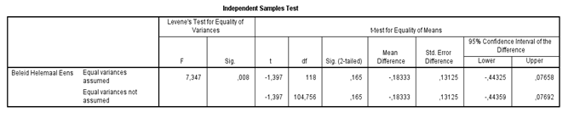

Wijk * Mate contact buurtbewoners Crosstabulation
 |  |  | Mate contact buurtbewoners |  |  | Total
 |  |  | Niet of nauwelijks | Matig | Veel | Total
Wijk | Zuiderburen | Count | 5 | 37 | 17 | 59
Wijk | Zuiderburen | Expected Count | 7,5 | 38,0 | 13,5 | 59,0
Wijk | Aldlân | Count | 10 | 39 | 10 | 59
Wijk | Aldlân | Expected Count | 7,5 | 38,0 | 13,5 | 59,0
Total |  | Count | 15 | 76 | 27 | 118
 |  | Expected Count | 15,0 | 76,0 | 27,0 | 118,0

Chi-Square Tests
 | Value | df | Asymptotic Significance (2-sided)
Pearson Chi-Square | 3,534ª | 2 | ,171
Likelihood Ratio | 3,587 | 2 | ,166
Linear-by-Linear Association | 3,501 | 1 | ,061
N of Valid Cases | 118
a. 0 cells (0,0%) have expected count less than 5. The minimum expected count is 7,50.

Appendix 3 – Map Leeuwarden ArcGIS

Appendix 4 – Checklist for ethical survey questions

Avoid leading questions | The words ‘no’ or ‘not’ should be avoided
Avoid jargon in the questions | Avoid asking two questions in one question
The survey must have a good structure | Avoid spelling or grammatical errors in the survey
There should be asked mainly closed questions | Questions should be kept as simple as possible
The questions in the survey together should be able to answer the central question | At the end of the survey, the respondent should be thanked for his/her cooperation
Avoid complex long words | The survey must be tested by friends and family

Appendix 5 – Data analysis scheme

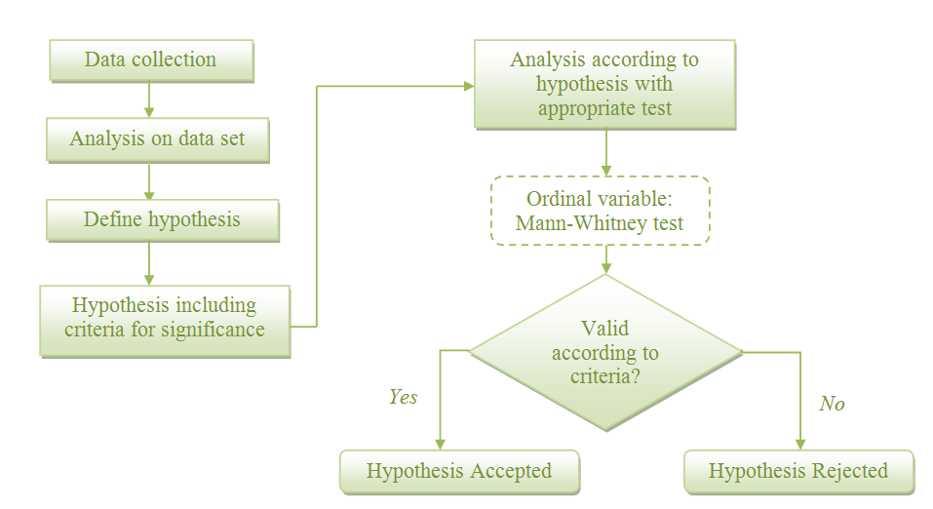

Appendix 6 – Word web for orientation of the subject

Appendix 7 – Timetable
Week | Date | Content | To do
7 | 16/2 | Session 1 | Start Assignment 1
7 |  | Own time | Continue Assignment 1
8 | 21/2 | 9.00 AM Deadline Assignment 1
8 | 23/2 | Session 2 | Start Assignment 2
8 |  | Own time | Continue Assignment 2
9 | 28/2 | Session 3 | Continue Assignment 2
9 |  | Own time | Continue Assignment 2
10 | 6/3 | 9.00 AM Deadline Assignment 2
10 | 7/3 | Session 4 | Start Assignment 3
10 | 8/3 | Personal session with Kuper | Talking about progress etc.
11 |  | Own time | Continue Assignment 3
12 | 20/3 | 9.00 AM Deadline Assignment 3
12 | 20/3 | Walk-in Lecture GIS | Ask questions
12 | 21/3 | Session 5 | Start Assignment 4
12 |  | Own time | Continue Assignment 4
13 | 27/3 | Walk-in Lecture Data (SPSS) | Ask questions
13 |  | Own time | Continue Assignment 4
14 | 3/4 | Exam Geography, Planning and the EU
14 |  | Own time | Continue Assignment 4
15 | 12/4 | Exam Philosophy of Social Science
15 |  | Own time | Continue Assignment 4
16 | 18/4 | Session 6 | Continue Assignment 4
16 | 18/4 or 19/4 | Deadline Assignment 4
16 | 20/4 | Fieldwork abroad
17 |  | Fieldwork abroad
18 |  | Fieldwork abroad
19 | 9/5 | Session 7 | Start Assignment 5
19 |  | Own time | Continue Assignment 5
20 | 16/5 | Open office Bachelor’s thesis | Continue Assignment 5
20 |  | Own time | Continue Assignments 5 & 6
21 | 22/5 | 9.00 AM Deadline Assignment 5
21 | 24/5 | 9.00 AM Deadline Assignment 6
21 |  | Own time | Continue with thesis
22 | 30/5 | 9.00 AM Deadline 2nd version thesis(5&6)
22 | 30/5 | 16.00 Individual session | Discussion Assignments 5 & 6
22 |  | Own time | Start Assignments 7 & 8
23 |  | Own time | Continue Assignments 7 & 8
24 | 12/6 | 9.00 AM Deadline Final version thesis (7)
25 | 19/6 | 9.00 AM Deadline Poster
25 | 26/6 | 13.00-15.00 Poster presentation
25 | 28/6 | Final session

Vinex-wijken zijn uitbreidingsplannen aan de rand van bepaalde grote steden. Deze plekken zijn aangewezen door de ‘Vierde Nota Ruimtelijke Ordening Extra’ uit 1991 (encyclo.nl).

